**Digital Electronics**

**The number system:** The number system or the numeral system is the system of naming or representing numbers.

**Weighted binary codes:** Weighted binary codes are those binary codes which obey the positional weight principle. Each position of the number represents a specific weight.

## Non-Weighted Codes: In this type of binary codes, the positional weights are not assigned. The examples of non-weighted codes are *Excess-3* code and *Gray code.*

Number Convertion:

* Any base to decimal: Coefficient*(base)power

(A2.3B)16 = (10 × 161) + (2 × 160) + (3 × 16-1) + (11 × 16-2)

* Decimal base to any: Divided by base when reminder is count from downward. (MSB to LSB)

For fractional number:

1. Multiply the fractional number with the to Base, to get a resulting number.  
    2. The resulting number has two parts, non-fractional part and fractional part.  
    3. **Record the non-fractional part** of the resulting number.  
    4. Repeat the above steps at least four times.  
    5. Write the digits in the non-fractional part starting from **upwards to downwards**.

* Binary to (Octal-Hexadcimal): (3-bit) and (4-bit)
* American Standard Code for information interchange.

**ASCII** encodes 128 specified [characters](https://en.wikipedia.org/wiki/Character_(computing)" \o "Character (computing)) into seven-bit integers. Ninety- five of the encoded characters are printable: these include the digits 0 to 9, lowercase letters a to z, uppercase letters A to Z, and [punctuation symbols](https://en.wikipedia.org/wiki/Punctuation_symbol" \o "Punctuation symbol). In addition, the original ASCII specification included 33 non- printing [control codes](https://en.wikipedia.org/wiki/Control_code" \o "Control code).

* The **[Unicode](https://en.wikipedia.org/wiki/Unicode_Consortium" \o "Unicode Consortium)** current version (15.0) is 149,186 characters covering 161 modern and historic [scripts](https://en.wikipedia.org/wiki/Script_(Unicode)" \o "Script (Unicode)), as well as symbols, thousands of [emoji](https://en.wikipedia.org/wiki/Emoji" \o "Emoji) (including in colours), and non-visual control and formatting codes. Unicode can encode up to roughly 1.1 million characters.
* Using N bits, we can represent decimal numbers ranging from 0 to 2N - 1, a total of 2N different numbers.
* T[wo's complement](https://en.wikipedia.org/wiki/Two's_complement" \o "Two's complement) allows a signed integral type with n bits to represent numbers from **−**2(n−1) through 2(n−1)**−**1

msL¨vwU abvZ¥K bvwK FYvZ¥K Zv eySv‡bvi Rb¨ mvaviYZ msL¨vi cÖK…Z gv‡bi Av‡M GKwU AwZiw³ weU (Bit) †hvM Kiv nq| G AwZwi³ weU‡K wPý weU (Sign Bit) e‡j| wPý weU 0 n‡j msL¨vwU abvZ¥K Ges wPýweU 1 n‡j msL¨vwU‡K FYvZ¥K aiv nq|

Overflow:

Overflow Occurs with respect to addition when 2 N-bit 2’s Complement Numbers are added and the answer is too large to fit into that N-bit Group.

Overflow occurs when:

1. Two negative numbers are added and an answer comes positive or
2. Two positive numbers are added and an answer comes as negative.

Overflow and Carry Conditions

• Carry flag: set when the result of an addition or subtraction exceeds fixed

number of bits allocated

• Overflow: result of addition or subtraction overflows into the sign bit

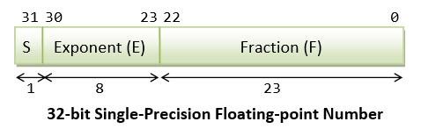Floating-point-representation:

32=100000

= 0.1000000*26

=0|00110|10000000

=0|Extra empty Bit fill from left| Extra empty Bit fill from right

=1sign Bit+5Exponent Bit+8Significant Bit

= a 14 Bit representation

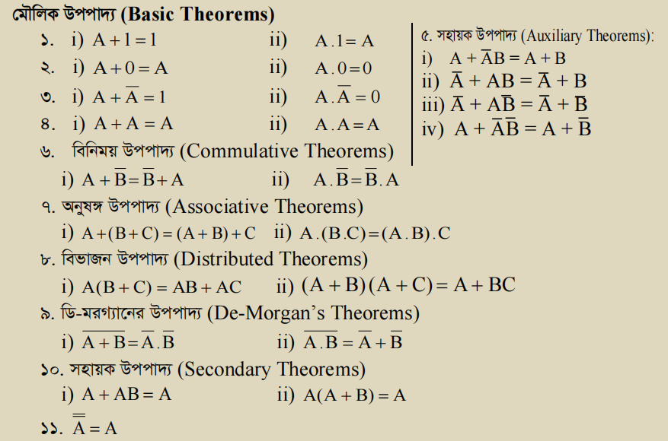

Different gate using AND and OR gate:

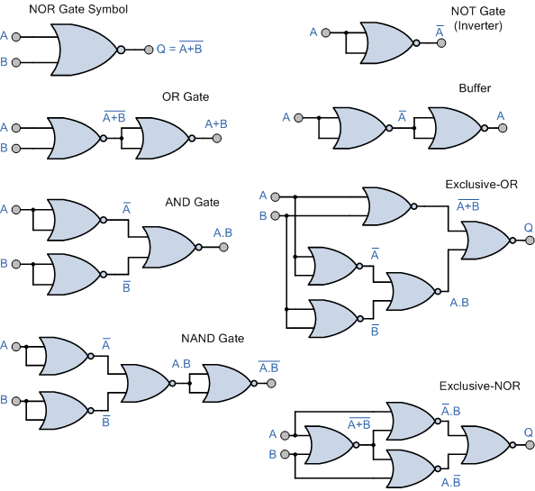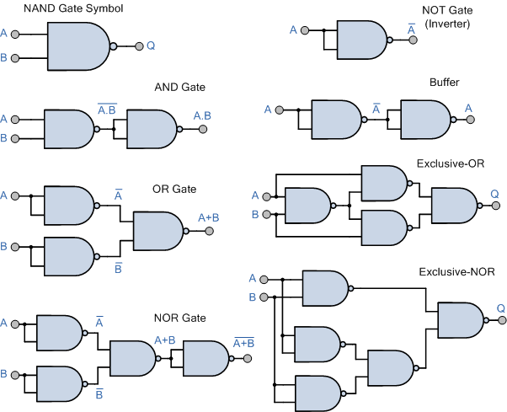

Consensus theorem in boolean algebra:

Redundancy theorem are:

1. Three variables must present in the expression.Here A, B and C are used as variables.
2. Each variables is repeated twice.
3. One variable must present in complemented form.
4. After applying this theorem we can only take those terms which contains the complemented variable.

**Error Detection Code:**

**The Gray code** defines a sequence of bit patterns in which only one bit

changes between successive patterns in the sequence.

Gray code, also known as reflected binary code, is a binary numeral system where two consecutive values differ by only one bit. It is designed in such a way that only one bit changes at a time during the transition from one value to the next. This unique property makes it useful in various applications where minimizing errors during transitions is crucial, such as rotary encoders, digital communication systems, and certain digital logic circuits.

Advantages of Gray Code:

1. **Minimal Bit Transitions:** When transitioning between consecutive values, only one bit changes, reducing the likelihood of errors in applications such as rotary encoders or digital communication systems. This reduces noise and makes it more suitable for error-sensitive applications.

2. **Used in Some Analog-to-Digital Converters (ADCs):** Gray code is used in some ADCs to minimize errors during transitions, ensuring accurate digital representation of analog signals.

3. **Reduces Error Propagation:** In applications where binary values represent states (e.g., digital logic circuits), Gray code minimizes the chance of errors propagating through multiple bits during transitions, making it useful for minimizing glitches and unexpected behavior.

Disadvantages of Gray Code:

1. **Non-Natural Representation:** Gray code doesn't have a direct correlation to the natural counting sequence, which can make it less intuitive for human interpretation and mental arithmetic.

2. **Inefficiency for Some Operations:** Certain mathematical and logical operations may be less efficient when using Gray code compared to standard binary representations, as these operations may require additional conversions.

3. **Limited Applicability:** Gray code's advantages are more pronounced in specific applications (like rotary encoders or error-sensitive digital systems). In other cases, the benefits may not be as significant, making it less universally applicable.

**BCD** code or Binary coded Decimal codes. It is a numeric weighted binary codes, where every digit of a decimal number is expressed by a separate group of 4-bits.

**Advantages of BCD Codes:**

It is very similar to a decimal system and relatively easy to convert to and from decimal.

It is required to remember the binary equivalent of decimal numbers from 0 to 9 only.

The conversion of binary to decimal and vice versa is important from the hardware viewpoint.

**Disadvantages of BCD Codes**

The addition and subtraction of BCD have separate rules.

The BCD calculation is a little more complex.

**Excess-3** code, also known as XS-3 or Gray-3 code, is a binary-coded decimal (BCD) representation in which each decimal digit is represented by a 4-bit binary code, similar to regular BCD. However, what sets Excess-3 apart is that it adds a constant value of 3 (0011 in binary) to the actual decimal digit before converting it to 4-bit binary.

Certainly, here's a concise overview of the advantages and disadvantages of Excess-3 code:

Advantages:

1. **Error Detection:** Excess-3 inherently detects single-bit errors during conversion, making it useful for error-sensitive applications.

2. **Uniqueness:** Each decimal digit has a unique 4-bit binary representation, preventing ambiguity.

Disadvantages:

1. **Wasted Space:** Some binary combinations are unused in Excess-3, leading to inefficient encoding.

2. **Limited Range:** Efficient only for representing digits 0 to 9, less practical for larger values.

3. **Modern Relevance**: Historically significant but less relevant in modern computing due to more efficient binary encoding options.

**Code:** When numbers, letters, or words are represented by a special group of

symbols, we say that they are being encoded, and the group of symbols is

called a code.

A straight binary number takes the complete decimal number and represents it in binary; the BCD code converts each decimal digit to binary individually.

To maintain the data integrity among transmitter and receiver, an additional bit is added with the transferred data. This extra bit is applied to detect as well as correct the error in the data.

The extra or additional bit with the data, together create the code. There are codes which are applied only to identify the error and are known as error-detecting codes and the one which assists in detection and correction of errors are acknowledged as error detecting and correcting codes.

* In a binary number, the bit furthest to the left is called the most significant bit (msb) and the bit furthest to the right is called the least significant bit (lsb).

The multiplication of two binary numbers comes down to calculating partial products (which are 0 or the first number), [shifting](https://en.wikipedia.org/wiki/Logical_shift" \o "Logical shift) them left, and then adding them together (a binary addition, of course):

**K-Map**

1. Only one bit change or difference can make group.

2. The cell that are overlap after fold only can be grouped.

3. Make less group but with max cell.

4. Consider don’t care value for max cell group.

5.

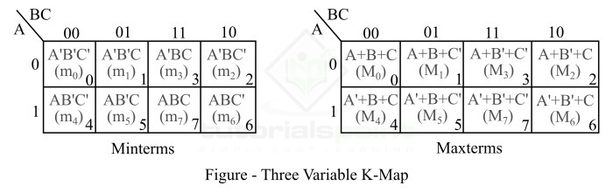

**Definition of Setup time**: Setup time is defined as the minimum amount of time before the clock's active edge that the data must be stable for it to be latched correctly. In other words, each flip-flop (or any sequential element, in general) needs some time for the data to remain stable before the clock edge arrives, such that it can reliably capture the data. This duration is known as **setup time**.

**Definition of Hold time**: Hold time is defined as the minimum amount of time after the clock's active edge during which data must be stable. Similar to setup time, each sequential element needs some time for data to remain stable after clock edge arrives to reliably capture data. This duration is known as **hold time**.

The noise immunity of a logic circuit refers to the circuit’s

ability to tolerate noise without causing spurious changes in the output volt

age.